Microbial genetics

Topic - Mechanism of conjugation

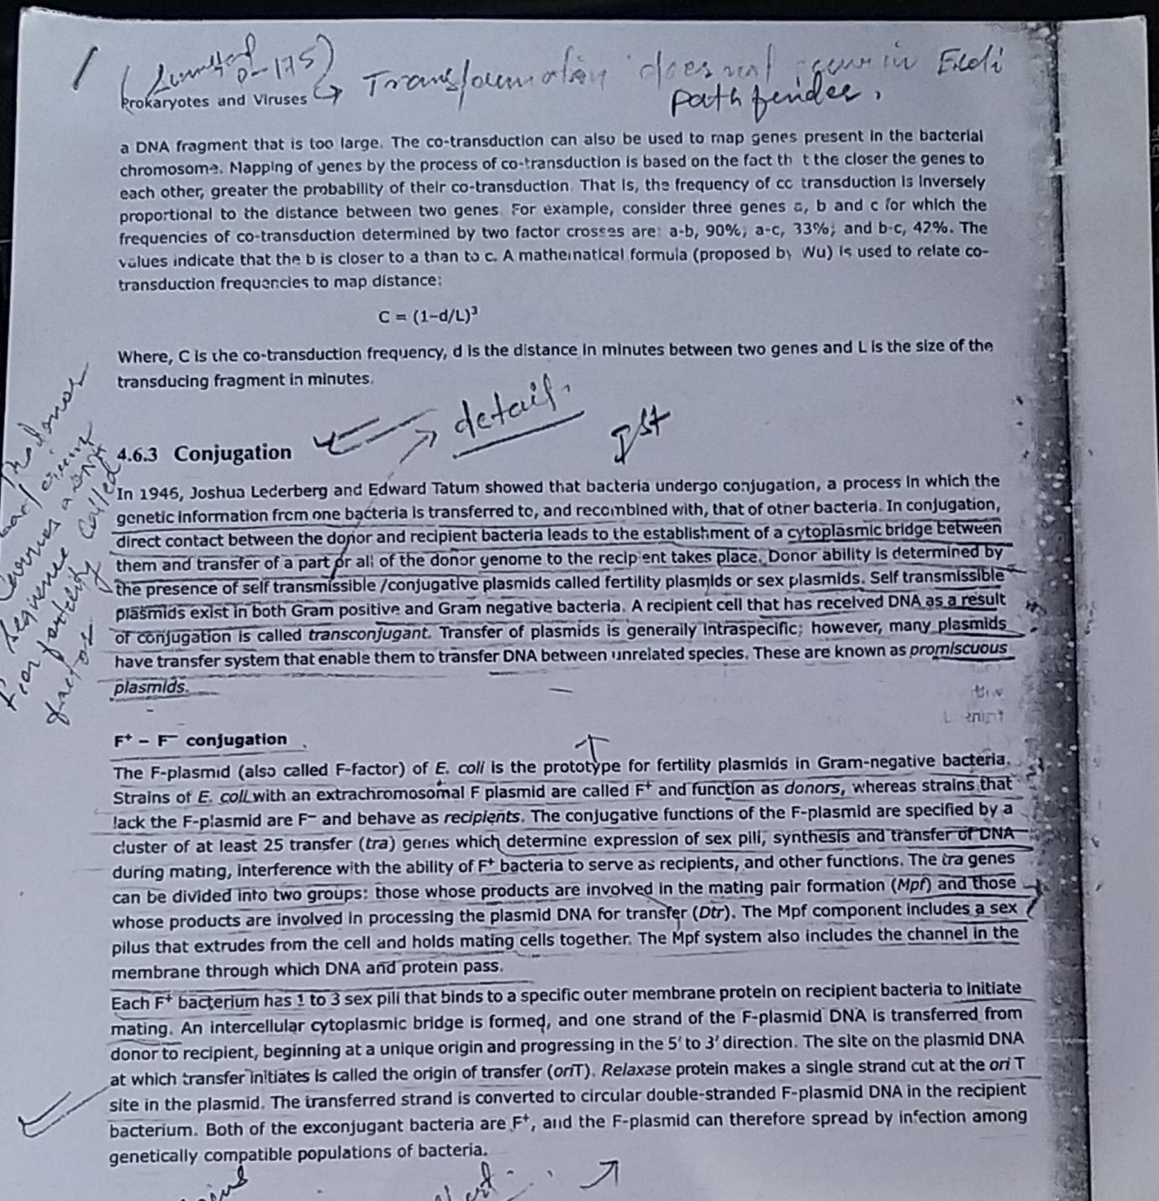

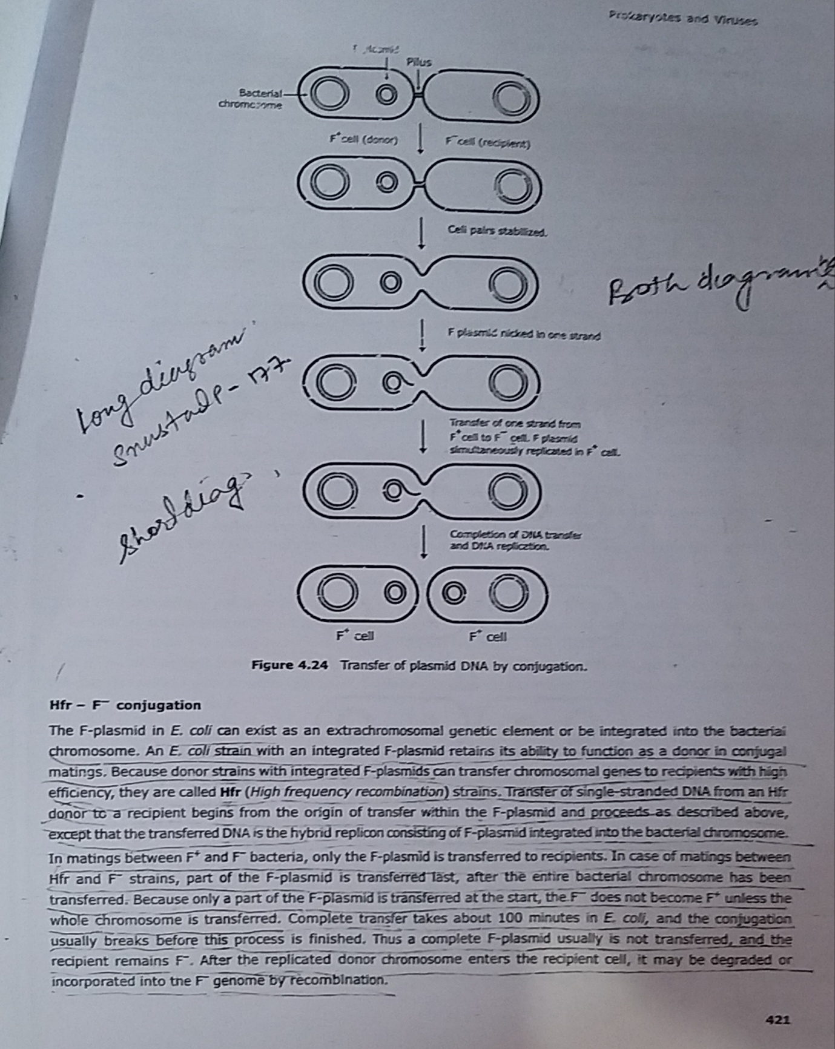
References:
Life Sciences-Fundamental and Practices Part -1
By Pranav Kumar and Usha Mina

